**GIT LAB ASSIGNMENT 1**

NAME: PRIYADHARSHINI N

ROLL NO: 731621121043

MAILID: [priyanarayanan2603@gmail.com](mailto:priyanarayanan2603@gmail.com)

1. **Create a local git repo with the name "MyRepo".**

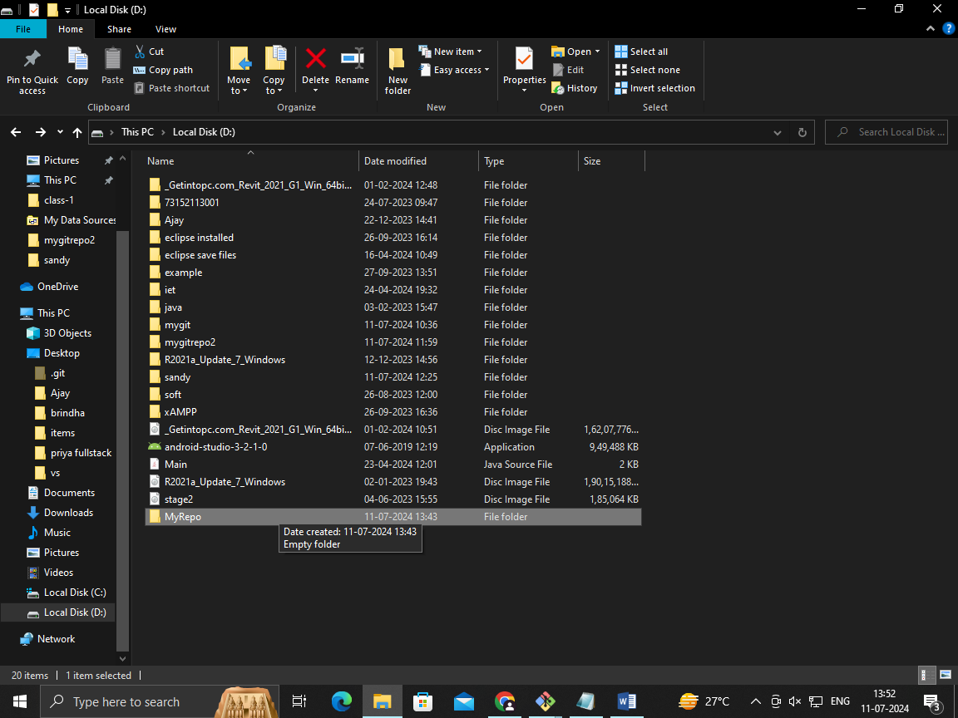

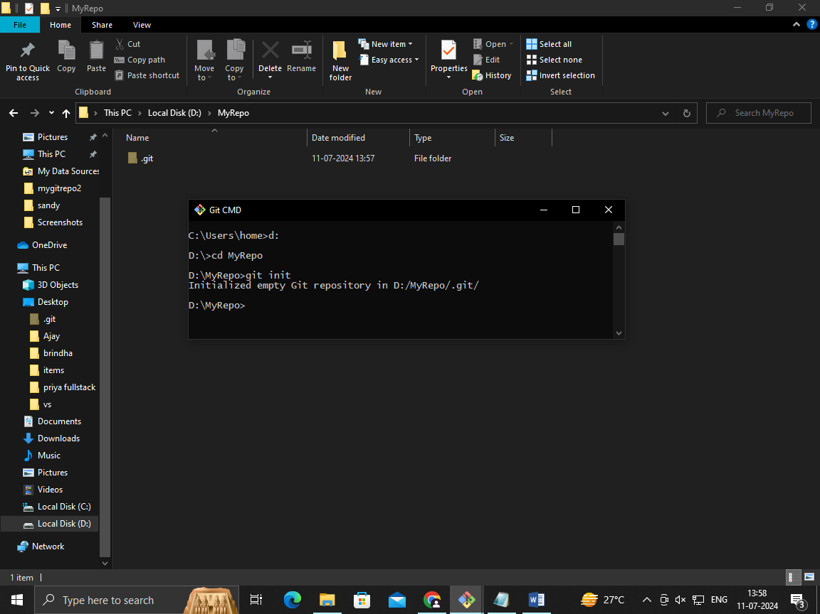

1. **create one .txt file, five .c files and five .java files in the working area**

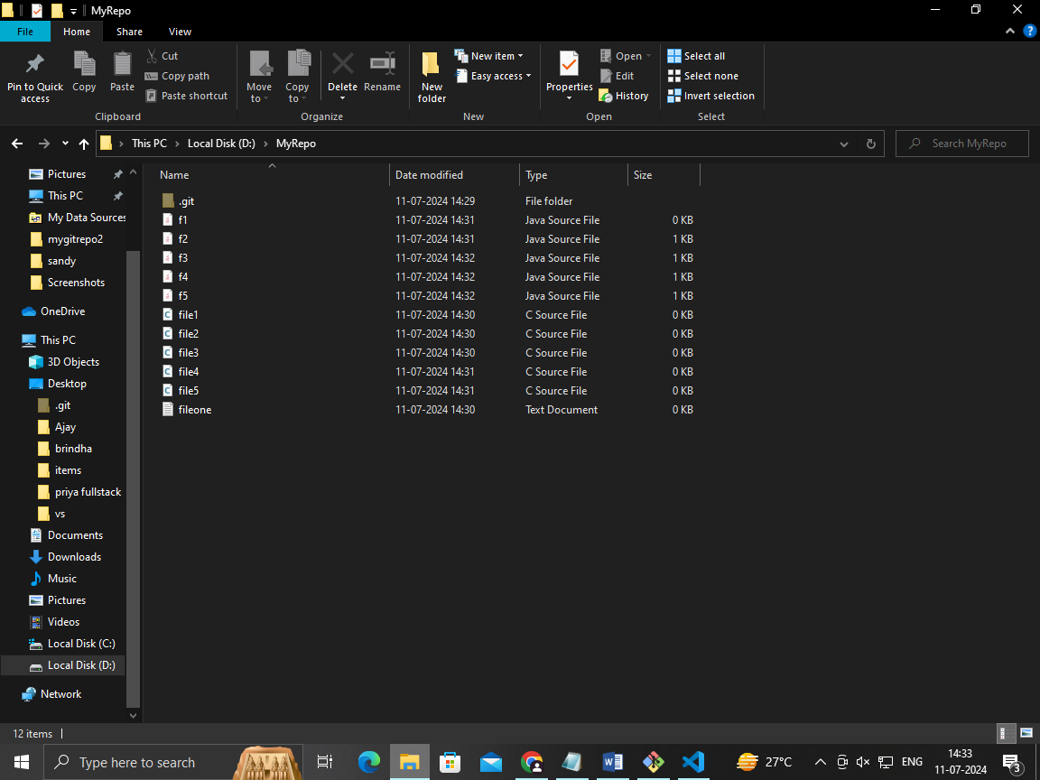

1. **Verify the git status**

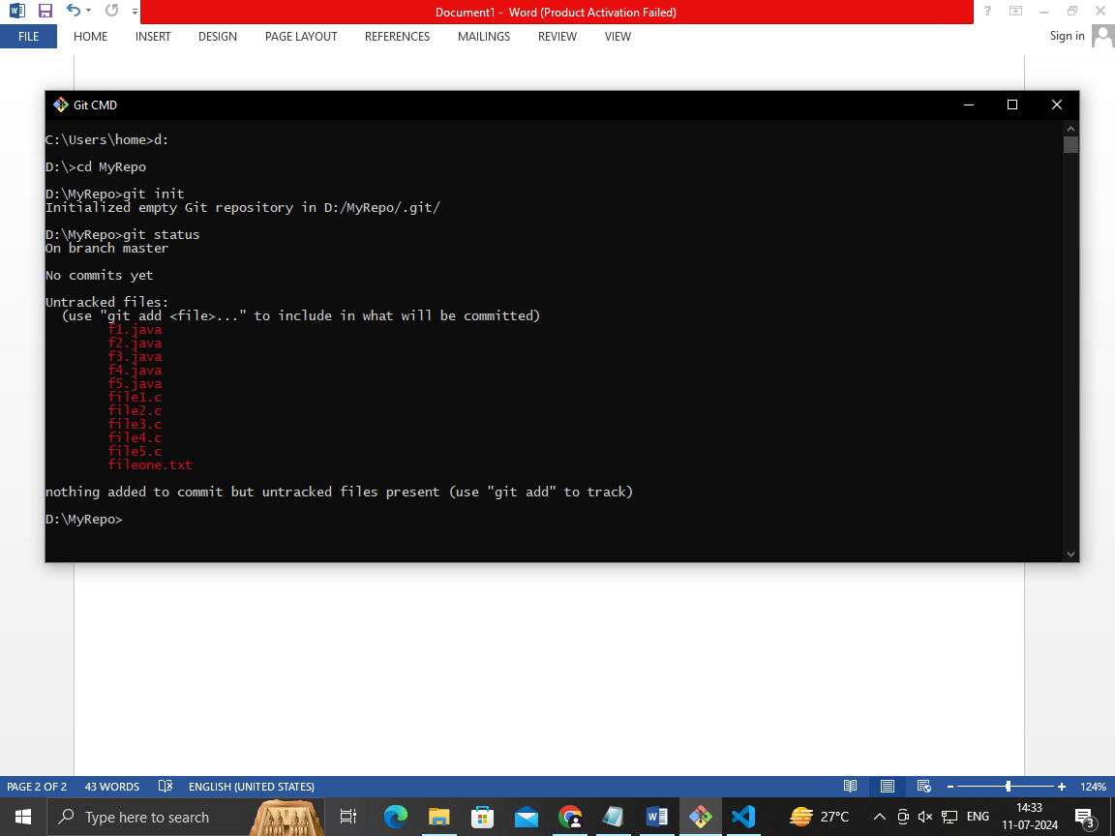

1. **Add only the .txt into the staging area**

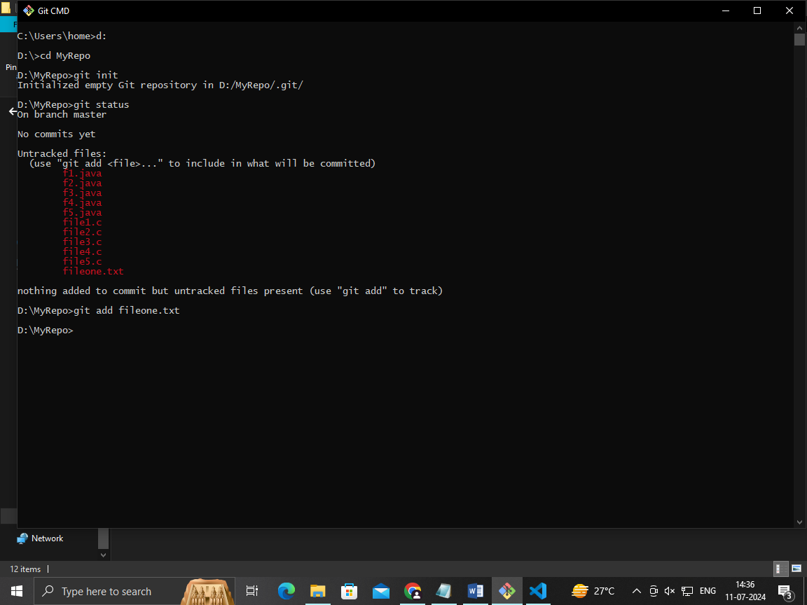

1. **verify the git status**

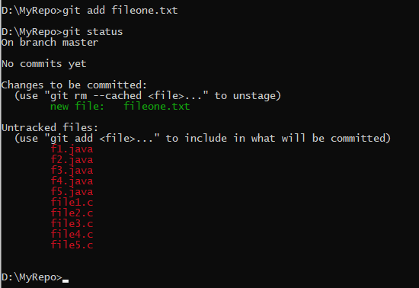

1. **Make a commit with the name "TXT Commit"**

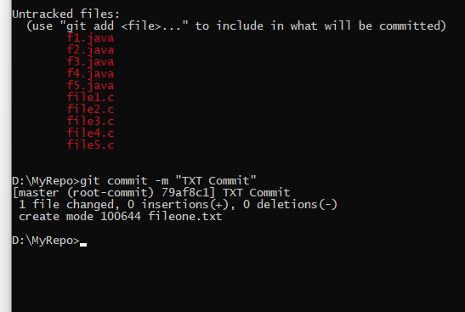

1. Add all .c files into the staging area



1. verify the git status

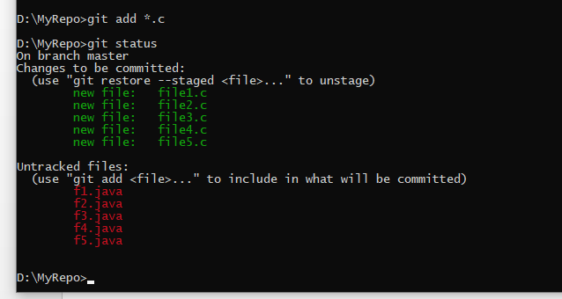

1. Make a commit with the name "C Commit"

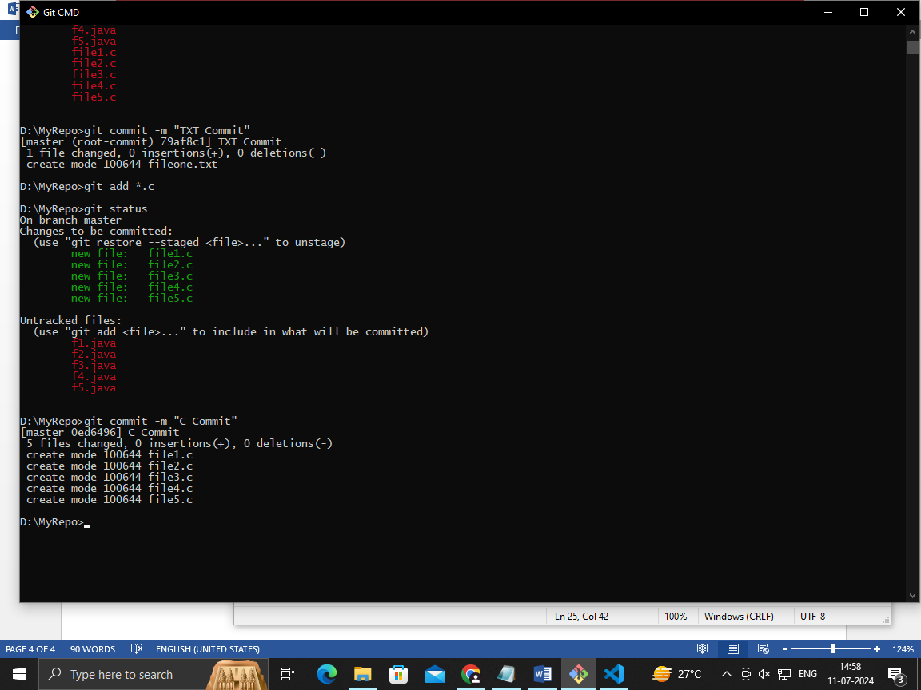

1. Add all .java files into the staging area

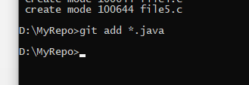

1. verify the git status

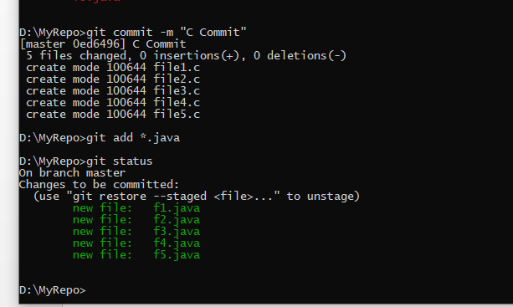

1. Make a commit with the name "Java Commit"

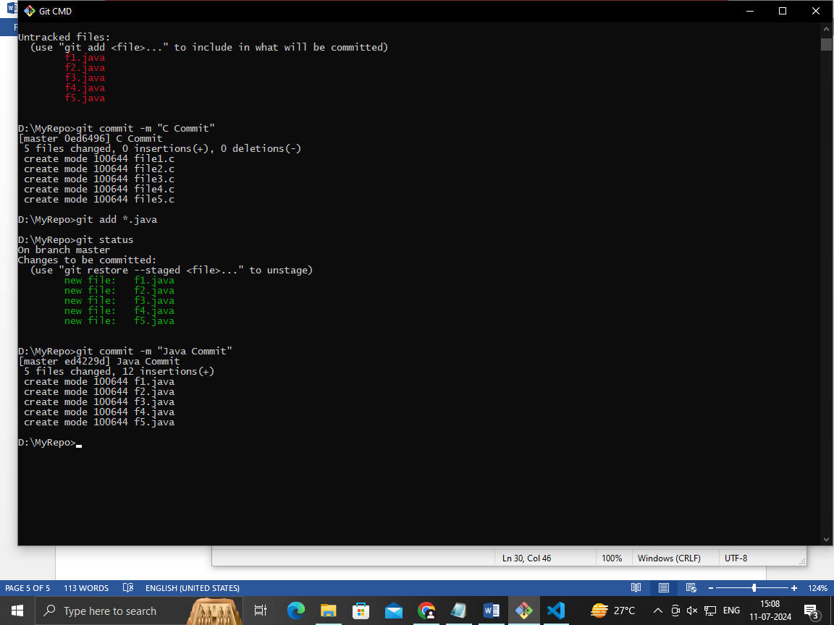

1. Delete all .java files from working area

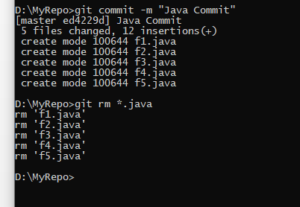

1. Now see the status

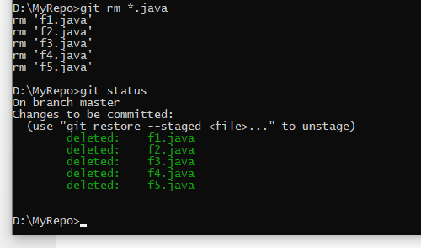

1. add the changes into the staging area

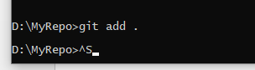

1. Make a commit with the name "Delete Java Commit"

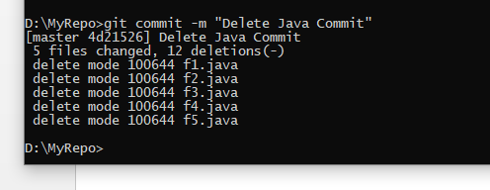

1. display all commit details

